Hardware User guide of MCU on motor control unit

# Preface

This document contains the features , connectors , pinouts , schematic design ,block diagram , hardware specification and board specifications

## 1)INTRODUCTION

## Overview :

This development board has the functionality to interface multiple sensors , with battery powered specification and output through relays.

## Features:

* Control of lights (front/rear indicators, headlight) 7 output connectors are given
* Accelometer sensor interface
* Bluetooth HM-10 interface
* EN and Reset pinout for efficient programming and debugging
* Power on LED
* SIM800C GPS module interface
* Operates in 12v battery
* Interface for current sensor , fuel sensor,tilt sensor, programming pins
* OLED B display interface with no buttons

# Board specifications

## Electrical specifications

Operates on a 12V battery with fuses enabled for a 5A current limit.

## Mechanical specifications:

Dimensions – 10cm x 15cm   
  
Type C charger for battery is allowed to place at edge of the board

# Hardware Overview :

## Main MCU : ESP32 wroom 32

## Connectors :

1)Bluetooth – 4pins – interface through UART

1. VCC
2. GND
3. Rx_BL – IO 16
4. Tx_BL – IO 17 ( While connecting UART module make sure Tx gone to RX and Rx gone to Tx)

2)Current sensor – 3 pins

1. Vin
2. OUT – IO34
3. GND

3)Tilt Sensor

1. VCC
2. GND
3. DO – GPIO 7

4)Accelerometer sensor – 8 pins – interface through SPI protocol

1. GND
2. VCC
3. CS – IO5
4. INT1 – IO32
5. INT2 – not connected
6. MISO – IO19
7. MOSI – IO23
8. SCK – IO18

5)Liquid Sensor

1. VCC
2. OUT_L
3. GND

6)Power supply – 12V

1. Vbat
2. GND

7)Programming Pins

1. Tx – IO1
2. Rx – IO3
3. Vcc
4. GND

8)OLED B – 8pins – interface through the I2C protocol

1. GND
2. VCC
3. SCL – IO22
4. SDA – IO21
5. K4 – not connected
6. K3 - not connected
7. K2 - not connected
8. K1 - not connected

9)SIM800C – mikro bus connections – interface UART

1. Vin – 5v
2. Vcc – 3.3
3. GND
4. Tx_s – SD2
5. Rx_s – SD3
6. PWK – IO25
7. GND

10) light connectors with relays

1. L1 – IO26
2. L2 – IO2
3. L3 – IO4
4. L4 – IO12
5. L5 – IO13
6. L6 -IO14
7. L7 -IO15

11)Fuel sensor

1. OUT_FS
2. GND

### Test points

7 test points have been added.

* Vcc
* Tx_Bl
* Rx_Bl
* SCL
* SDA
* Boot
* Reset

## Block diagram

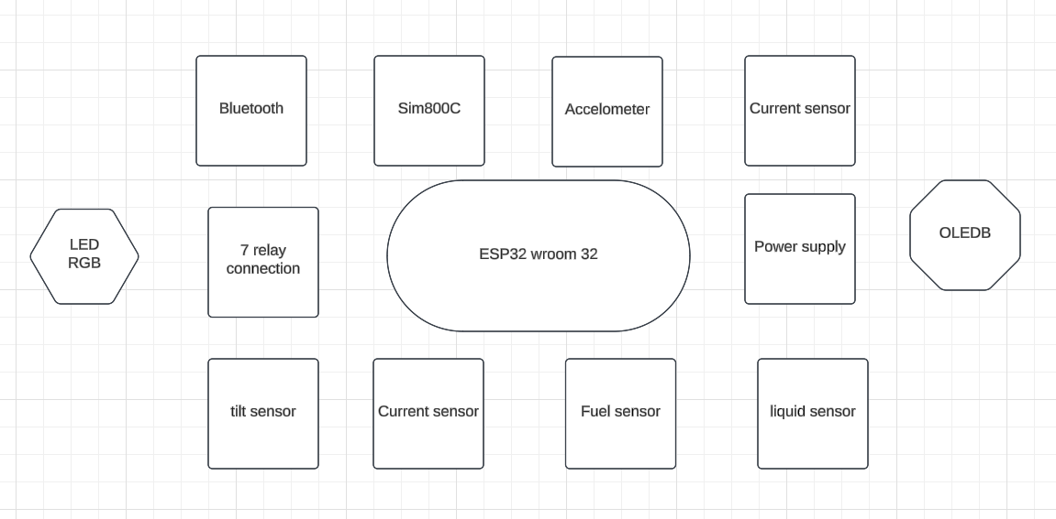

## PCB picture

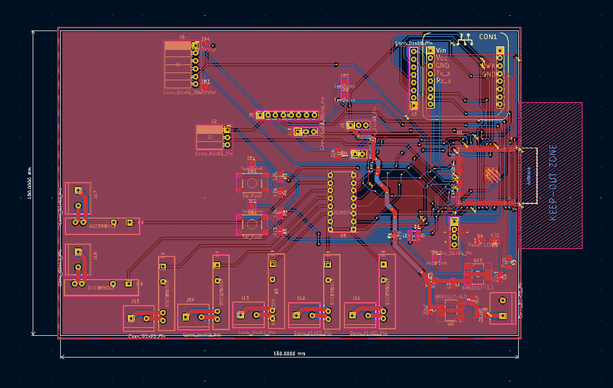  
  
  
Revision   
  
1) The footprint of relay is missing - Please check the BOM for the new footprint that is assigned